CLANG++ MANUAL

- Create toolchain
python $NDK/build/tools/make_standalone_toolchain.py --arch <abi> --api <level> --install-dir <path>
- Extra toolchain from zip file

- Build object file
arm-linux-androideabi-clang++ -c ./src/Calculator.cpp -o ./bin/Calculator.o -I ./include --sysroot=sysroot

- Build shared library
arm-linux-androideabi-clang++ -shared ./bin/Calculator.o -o ./lib/armeabi-v7a/libcalculator.so --sysroot=sysroot

- Build static library
arm-linux-androideabi-ar.exe -rcs ./lib/Calculator.a ./bin/Calculator.o

- Folder tree overview
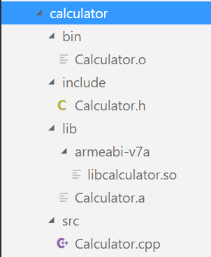

- Build script overview
